

**Team Members:**

**Marwan Ayman 17107676**

**Al-Farouk Ahmed 17107672**

**Database Systems**

**IS373**

**Under the supervision of:**

**Dr. Nashwa El-Bendary**

**Eng. Islam Atef**

**Problem Statement**

A company built an application that allows parents to track their children’s’ school buses. Information about **Users**, institutions, buses, trips and **stations** are stored in the database.

For Each **user** the company stores: Name (first name & last name), (phone Number & ID) which are his Primary key and his Password.

A User can be **Admin**, **Driver** or **Parent.** Every **User** must belong to one of the above, and no **User** can belong to more than one of them.

For each **Institution** the company stores: Institution ID (which is unique), Name, Location & Phone number. For Each **Bus** the App stores: Plate Number (which is unique) & Bus Type. And for Each **Trip** it stores: Trip ID (which is unique), Trip Time & Trip Type. Finally, for Each **Station** it stores: Station ID (which is unique), Station Name & Station Location. Every **Institution** owns one or more **buses,** while Each **bus** is owned by one and only one **Institution.** Every **Admin** operates one and only one **Institution,** while Every **Institution** is operated by one or many **Admins.** Every **Bus** may be driven by one or more **Drivers,** while Each **Driver** may drive one or more **Buses.** Each **Driver** may start one or more **Trips,** while Each **Trip** can only be started by only one **Driver.** Each **Trip** has one or more **Stations,** while each station has one or more **trips**. Each **Parent** can Track one or more **Trips**, while each **Trip** may be tracked by one or more **parents**. The company finds that it needs to store the Station_Order to ease the transportation process, so it adds it.

**EERD**

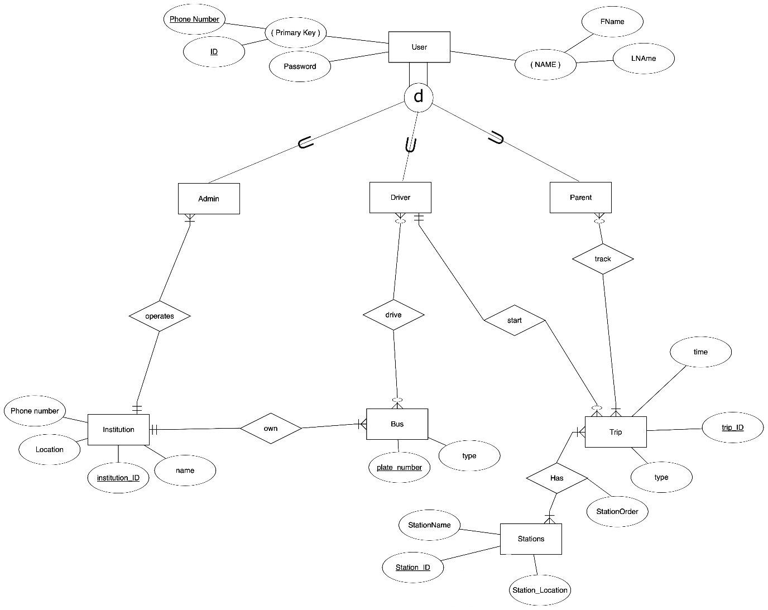

**Relational Schema**

**User**

|  |  |  |  |  |
| --- | --- | --- | --- | --- |
| ID | PhoneNumber | Password | FirstName | LastName |

**Driver**

|  |  |
| --- | --- |
| Driver_ID | PhoneNumber |

**Parent**

|  |  |
| --- | --- |
| Parent_ID | PhoneNumber |

**Admin**

|  |  |  |
| --- | --- | --- |
| Admin_ID | Phone Number | Institution_ID |

**Trip**

|  |  |  |  |  |
| --- | --- | --- | --- | --- |
| Trip_ID | Time | Type | Driver_ID | PhoneNumber |

**Bus**

|  |  |  |
| --- | --- | --- |
| PlateNumber | Type | Institution_ID |

**Institution**



|  |  |  |  |
| --- | --- | --- | --- |
| Institution_ID | Name | Location | Phone Number |

**Driver_Drive_Bus**

|  |  |  |
| --- | --- | --- |
| Driver_ID | PhoneNumber | PlateNumber |

**Parent_Track_Trip**

|  |  |  |
| --- | --- | --- |
| Parent_ID | PhoneNumber | Trip_ID |

**Trip_Has_Stations**

|  |  |  |
| --- | --- | --- |
| Trip_ID | Station_ID | Station_Order |

**Station**

|  |  |  |
| --- | --- | --- |
| Station_ID | Station Name | Station_Location |

**SQL Queries Screenshots**

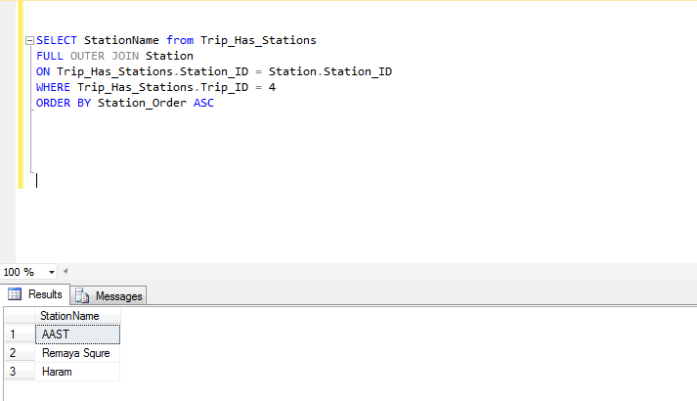

**1**

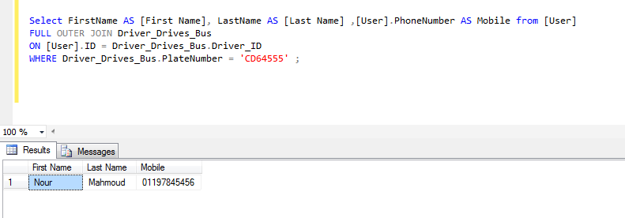

**2**

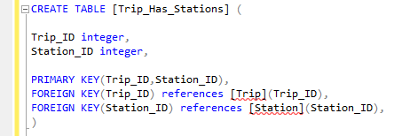

**3**

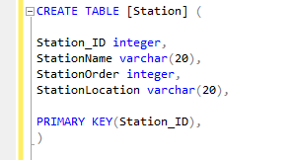

**4**

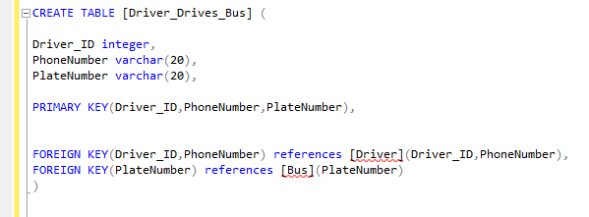

**5**

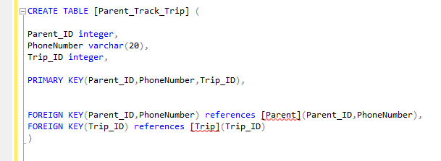

**6**

**Application Screenshot**

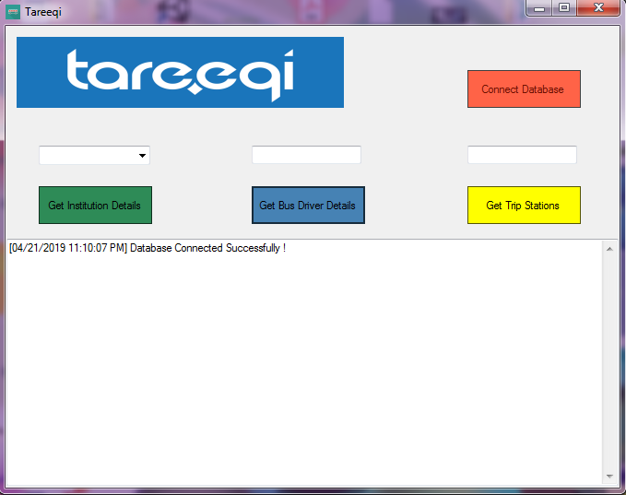

**SQL Data Tables Screenshots**

